OSSP (Operating Systems And Systems Programming) - 25CS2104E

PRACTICAL-2

- Develop a C program that uses the system calls open(), read(), write(), and close() to copy the contents of one file to another. Explain how control transitions between user space and kernel space during execution.
Use the strace utility to trace all system calls generated by the command cat sample.txt. Analyze the sequence of system calls and identify the kernel services involved.

STEP-1: Open Terminal

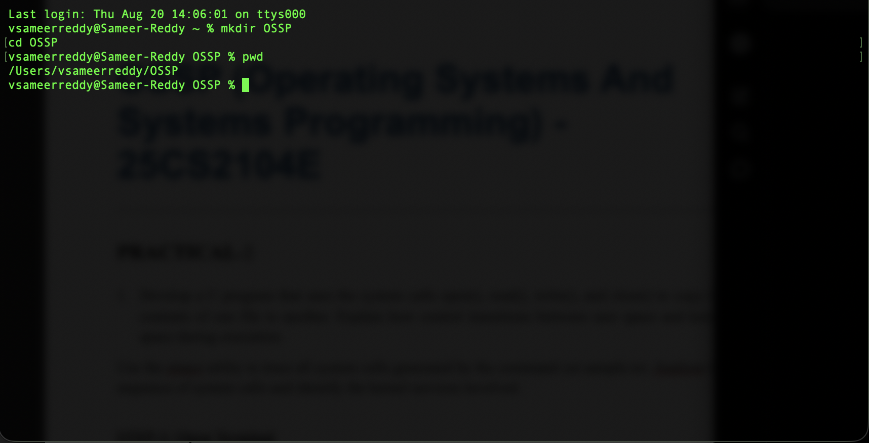
STEP-2 : Create a Folder

STEP-3: CREATE THE C PROGRAM

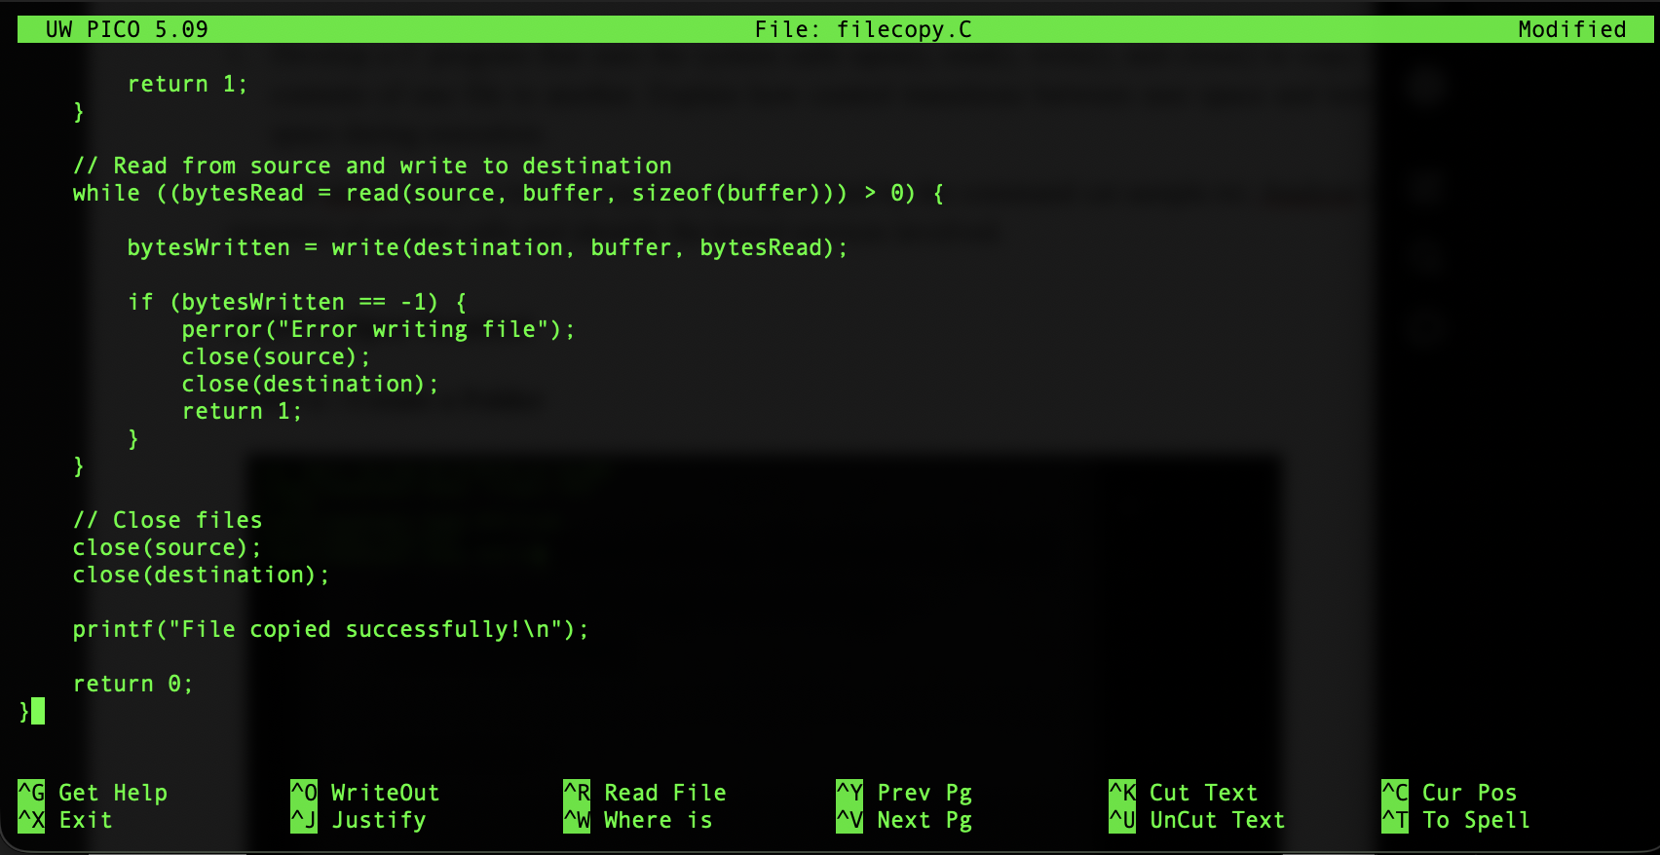

STEP 4: Saave the File in Nano
Control + O
Enter
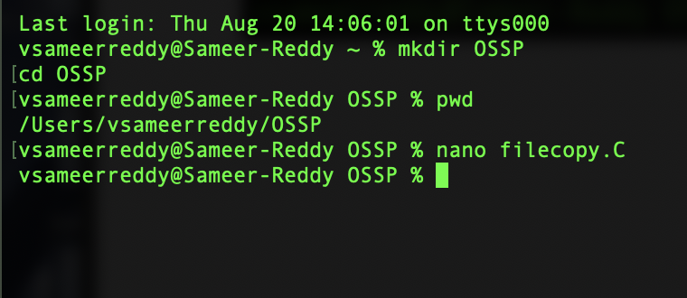
Control + X

STEP 5: Create smaple.txt
Type :
nano sample.txt

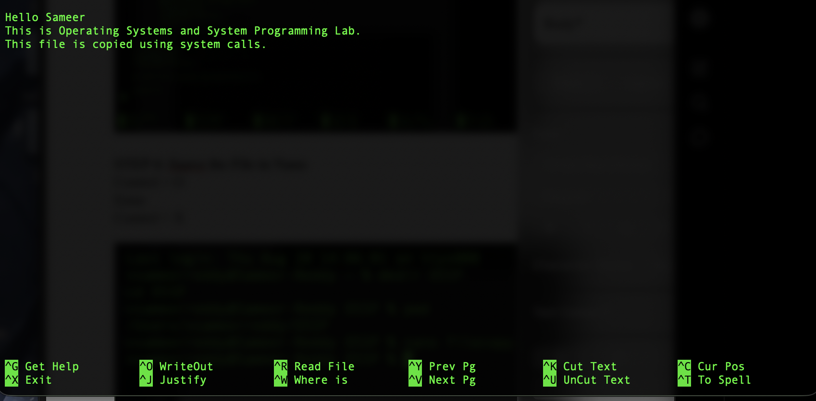
Write

STEP-6 : Compile the program
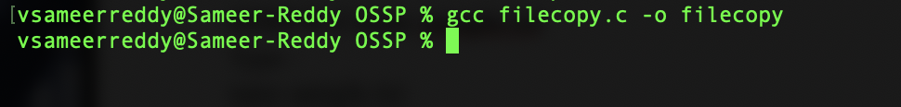

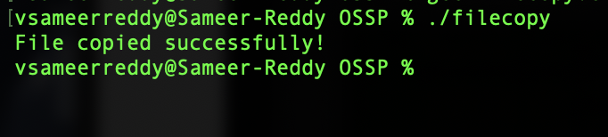
If there are no errors,run

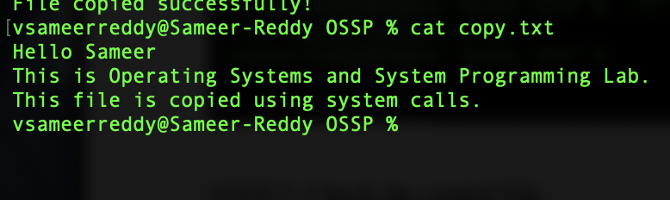
STEP 7: Check the copied File

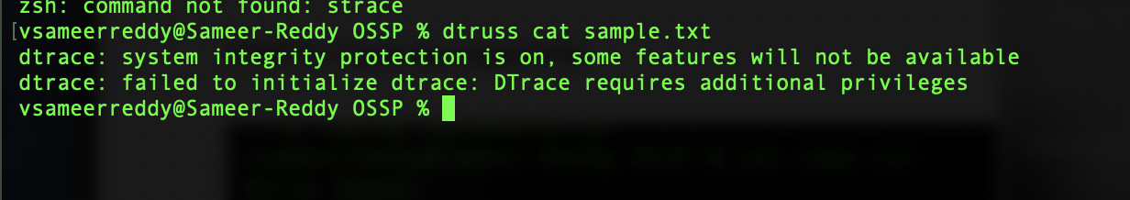
STEP 8: STRACE

